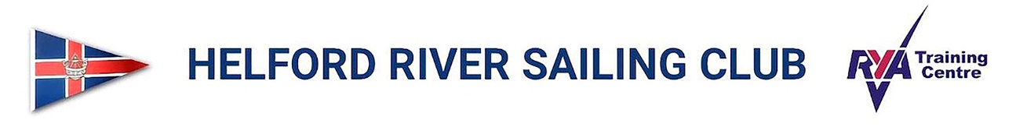
Helford, Helston Cornwall TR12 6LB
Clubhouse Tel: 01326 231606 Office Tel: 01326 231006
Email: admin@helfordriversc.co.uk

DRYING MOORING APPLICATION 2024

MOORING No: MEMBERSHIP No:

PLEASE COMPLETE THE WHOLE FORM.

Name: ……………………..……………………………………………………………………

Address:………………………………………………………………….. ……………………….

Tel No: ………………………………….. Email……………………………………...............

I wish to retain the Drying Mooring allocated to me for the boat described below:-

Boat Name:……………………....... Boat Length: under 22ft………………………

Boat Type:…….…………………… Weight : ……..………… Draft: ……………………

I enclose the payment of £590.00 for a mooring.

Drying Mooring fees are payable for the period 1st April 2024 to 31st October 2024

The Member accepts that the distance between moorings is so calculated as to provide clear swinging room for the vessels authorised to occupy them under normal circumstances. There may, however, be circumstances of wind and tide in which adjacent vessels may make contact with one another or adjacent mooring buoys and associated equipment. In accepting this agreement, the Member accepts this possibility and agrees to indemnify HRSC and its agents against all claims for damage so caused by or to their vessel.

I also require a permit to store a tender on the pontoon: Yes/No

I enclose the payment of £125 for a tender, under 3.25 metres only (please complete additional form)

Total enclosed £ ………………………………………………………………………………….

Club Bye Law No: 9 All boats using the Club premises or participating in any Club event or using the Club Mooring facilities shall be insured for third party risks. The amount of cover shall be £2,000,000

Name of insurance company: …………………………………………………………………..

Only the nominated boat above shall be placed on the pontoon. If you change your boat please contact the Club administrator. A new form and correct details must be given before placing a change of vessel on the premises.

Signed ….………………………………………Date …………………………………

I enclose payment of £………..

Please make payment to Helford River Sailing Club by BACS, Sort Code: 30-94-07

Acc. No: 00090120 with ‘Your surname Drying Mooring’ as the referenc or make cheques payable to HRSC and send to: Helford River Sailing Club, Helford, Helston, Cornwall, TR12 6LB

